ShopEZ
Microservices E-Commerce Platform
Backend Architecture & Technical Documentation
Submitted By  Yash Mishra | Batch  Batch 3 — Angular
Trainer  Narasimha Rao | Technology  ASP.NET Core 8 + Docker
Project  ShopEZ — E-Commerce Platform | Date  May 16, 2026

6  Microservices | 19  API Endpoints | 460  Unit Tests | 7  Docker Containers | 4  Databases

1. Introduction

ShopEZ is a fully containerised, cloud-ready e-commerce backend built on the microservices architectural pattern using ASP.NET Core 8. The system decomposes a monolithic shopping application into six independently deployable, single-responsibility services: Gateway, UserService, ProductService, CartService, OrderService, and PaymentService. Each service owns its own domain data, exposes a RESTful HTTP API, and communicates exclusively through the Ocelot API Gateway, which acts as the single ingress point for all client traffic.

The backend implements the complete e-commerce lifecycle: user registration and authentication via BCrypt-hashed passwords and JWT tokens, product catalogue management with paginated Dapper-based search, an in-memory shopping cart with stock-aware item management, EF Core-persisted order placement with a six-state status machine, and payment processing via a deterministic mock gateway with refund support. The entire system is orchestrated through a single docker-compose.yml that brings up all seven containers — including a SQL schema initialisation service — in the correct dependency order.

📊 System Overview — ShopEZ Microservices Platform
mermaid
graph LR
Client([Angular SPA :4200]) -->|HTTP| GW[Ocelot Gateway :5000]
GW -->|/api/auth/*| US[User Service :5001]
GW -->|/api/products/*| PS[Product Service :5002]
GW -->|/api/cart/*| CS[Cart Service :5003]
GW -->|/api/orders/*| OS[Order Service :5004]
GW -->|/api/payments/*| PAY[Payment Service :5005]
US --> UDB[(ShopEZ_UserDb)]
PS --> PDB[(ShopEZ_ProductDb)]
CS --> MEM[(In-Memory Store)]
OS --> ODB[(ShopEZ_OrderDb)]
PAY --> PAYDB[(ShopEZ_PaymentDb)]
style GW fill:#1B4F9E,color:#fff
style Client fill:#E67E22,color:#fff

1.1 Project Objectives
- Implement a production-grade microservices backend in ASP.NET Core 8 targeting net8.0
- Enforce JWT-based authentication (HmacSha256, ClockSkew=Zero) with role-based authorisation (Admin / Customer)
- Persist domain data in isolated SQL Server databases per service using EF Core 8 (User, Order, Payment) and Dapper 2.1 (Product)
- Deploy the complete system as Docker containers via docker-compose with health-checked dependency ordering
- Achieve 460 passing unit tests across 5 xUnit test projects with Moq and EF InMemory

1.2 Scope
This documentation covers exclusively the backend solution contained in the ShopEZ.MicroServices.API Visual Studio solution (.slnx), comprising 6 source projects, 5 test projects, 1 docker-compose.yml, 4 Dockerfiles, 1 SQL DDL schema file, and 3 EF Core migration sets. Frontend (Angular SPA) is out of scope.

2. Problem Statement

Traditional monolithic e-commerce applications tightly couple all business domains — user identity, product catalogue, cart management, order processing, and payment — into a single deployable unit. This architecture creates several critical engineering problems in real-world systems:

Problem Area | Monolithic Challenge | ShopEZ Solution
Scalability | Entire app must scale even if only product browse traffic spikes | Each service scales independently; ProductService can be replicated without touching PaymentService
Deployment Risk | A payment bug fix requires redeploying the entire catalogue, cart, and auth modules | Each Docker image (shopez/payment-service:latest) deploys independently
Technology Lock-in | All domains must use the same ORM and database driver | ProductService uses Dapper+raw SQL; others use EF Core 8 — chosen per domain needs
Data Isolation | A schema migration in Orders can break the User registration flow | 4 separate SQL Server databases: ShopEZ_UserDb, _ProductDb, _OrderDb, _PaymentDb
Fault Isolation | A crash in the payment module takes down the entire storefront | Gateway health checks ensure downstream services are healthy before accepting traffic
Testability | Unit testing one domain requires bootstrapping the entire application context | 460 tests in 5 isolated xUnit projects; each project mocks only its own dependencies

The system also addresses the problem of secure, stateless authentication across service boundaries. Because each microservice independently validates JWTs using a shared symmetric key (configured via docker-compose environment variables), no centralised session store is required, and any service can verify any token without network round-trips.

3. Proposed System

ShopEZ implements a synchronous, REST-over-HTTP microservices architecture. Six ASP.NET Core 8 services are deployed as Docker containers on a dedicated bridge network (172.20.0.0/16). An Ocelot API Gateway (v23.3.3) serves as the single entry point, routing all client requests to the appropriate downstream service by path prefix. JWT tokens issued by UserService are validated independently by every downstream service using the same HMAC-SHA256 symmetric key.

3.1 Service Responsibilities
Service | Port | DB Technology | Database | Responsibility
ShopEZ.Gateway | :5000 | None | None | Ocelot reverse proxy, CORS (localhost:4200), health aggregation
ShopEZ.UserService | :5001 | EF Core 8 | ShopEZ_UserDb | Registration (BCrypt workFactor:12), login, JWT issuance (24hr expiry, HmacSha256)
ShopEZ.ProductService | :5002 | Dapper 2.1 | ShopEZ_ProductDb | Full CRUD + paginated search (OFFSET/FETCH), NOLOCK reads, OUTPUT INSERTED.* writes
ShopEZ.CartService | :5003 | In-Memory | None (volatile) | Stock-aware cart via ConcurrentDictionary singleton, price snapshot at add time
ShopEZ.OrderService | :5004 | EF Core 8 | ShopEZ_OrderDb | Order creation (cascade insert Orders+OrderItems), 6-state status machine (Admin-only progression)
ShopEZ.PaymentService | :5005 | EF Core 8 | ShopEZ_PaymentDb | MockPaymentGateway (last4=0000 decline, 9999 timeout, else 95% approval), refund support

3.2 Key Design Decisions

3.2.1 Ocelot Gateway — No JWT Validation at Edge
The Gateway forwards the Authorization header to downstream services without validating it. JWT validation occurs exclusively within each service's ASP.NET Core authentication middleware. This means: (a) the gateway stays stateless and configuration-only, (b) each service independently enforces its own role policies, and (c) no shared token store is required between the gateway and services.

3.2.2 Dapper for ProductService
ProductService uses Dapper 2.1 + Microsoft.Data.SqlClient 5.2.1 instead of EF Core. The schema is managed via SqlSchema.sql executed at deploy-time by the sql-schema-init Docker service. This design choice enables: fine-grained SQL control (NOLOCK hints for all reads, OUTPUT INSERTED.* for atomic insert-and-return, QueryMultiple for count+data in one batch), a covering index strategy (IX_Products_Name_Price INCLUDE all columns), and avoidance of ORM overhead for a high-read catalogue endpoint.

3.2.3 In-Memory CartService
CartService stores all cart data in a static ConcurrentDictionary<int, Cart> registered as a Singleton. Carts are intentionally ephemeral — they survive between requests but not service restarts. This eliminates a database dependency for the cart domain, keeping the service lightweight and fast. The trade-off (data loss on restart) is acceptable for a session-scoped cart that is converted to a persistent Order upon checkout.

3.2.4 Auto-Migration on Startup
UserService, OrderService, and PaymentService each call db.Database.Migrate() at startup using a DI scope. Combined with EnableRetryOnFailure(3, 5s) on the SQL connection, this ensures that the database schema is always current and the service will wait for SQL Server availability before accepting traffic.

4. Tech Stack Details

4.1 Core Framework & Runtime
Component | Version | Usage
ASP.NET Core | net8.0 | Web framework for all 6 services; Kestrel HTTP server; minimal API hosting model
C# | 12 | Primary language; top-level statements in Program.cs; record types in DTOs
Entity Framework Core | 8.0.0 | ORM for UserService, OrderService, PaymentService; Code-First migrations; cascade delete; decimal precision mapping
Dapper | 2.1.35 | Micro-ORM for ProductService; raw SQL with NOLOCK, OUTPUT INSERTED.*, QueryMultiple
Microsoft.Data.SqlClient | 5.2.1 | SqlConnection factory for Dapper in ProductService
Ocelot | 23.3.3 | API Gateway; ocelot.json route table; UseOcelot() terminal middleware

4.2 Security & Authentication
Package | Version | Role
BCrypt.Net-Next | 4.0.3 | Password hashing with workFactor:12 in AuthService.RegisterAsync; Verify() in LoginAsync
Microsoft.AspNetCore.Authentication.JwtBearer | 8.0.0 | JWT Bearer middleware; ValidateIssuer, ValidateAudience, ValidateLifetime, ValidateIssuerSigningKey = true; ClockSkew = Zero
Microsoft.IdentityModel.Tokens | 7.3.1 | SymmetricSecurityKey, SigningCredentials, TokenValidationParameters
System.IdentityModel.Tokens.Jwt | 7.3.1 | JwtSecurityTokenHandler, JwtSecurityToken; Claims: Sub, Email, Jti, NameIdentifier, Name, Role

4.3 API Documentation & Health
Package | Version | Role
Swashbuckle.AspNetCore | 6.5.0 | Swagger UI at /swagger on all 5 services; Bearer SecurityDefinition; unconditionally enabled
HealthChecks.EntityFrameworkCore | 8.0.0 | AddDbContextCheck<T>() for User, Order, Payment services; /health endpoint used by docker-compose

4.4 Testing
Package | Version | Role
xunit | 2.9.0 | Test framework; [Fact] and [Theory] attributes across 460 test methods
Moq | 4.20.70 | Interface mocking for controllers and service layer tests
Microsoft.EntityFrameworkCore.InMemory | 8.0.0 | In-memory DB for UserRepositoryTests, OrderRepositoryTests
Microsoft.AspNetCore.Mvc.Testing | 8.0.0 | WebApplicationFactory for integration-style controller tests
coverlet.collector | 6.0.2 | Code coverage collection during dotnet test
Microsoft.NET.Test.Sdk | 17.10.0 | Test host and runner infrastructure

4.5 DevOps & Infrastructure
Technology | Version/Detail | Role
Docker | Multi-stage | sdk:8.0 build stage → aspnet:8.0 runtime stage; non-root appuser; curl installed for healthcheck
docker-compose | 7 services | shopez-network bridge 172.20.0.0/16; depends_on with service_healthy conditions; restart: unless-stopped
SQL Server | 2022-latest | Host-machine SQL Server at host.docker.internal:1435; 4 isolated databases
Visual Studio | .slnx format | ShopEZ.Microservices.slnx solution; 11 projects organised in src/ and tests/ solution folders

5. System Design

5.1 Architecture Diagram
The system follows a microservices architecture with an API Gateway pattern. The Angular SPA communicates exclusively with the Ocelot Gateway on port 5000. The gateway routes requests by URL path prefix to downstream services on ports 5001–5005. Each service owns its own database. There is no direct service-to-service communication — all inter-service workflows are frontend-orchestrated.

📊 Microservices Architecture — ShopEZ Backend
mermaid
graph TB
subgraph Client Layer
ANG([Angular SPA\nlocalhost:4200])
end
subgraph Gateway Layer
GW[Ocelot API Gateway\nshopez-gateway :5000\nOcelot 23.3.3]
end
subgraph Service Layer — shopez-network 172.20.0.0/16
US[User Service :5001\nBCrypt + JWT Issuer\nEF Core 8]
PS[Product Service :5002\nDapper 2.1\nNoSQL DDL Schema]
CS[Cart Service :5003\nConcurrentDictionary\nNo DB]
OS[Order Service :5004\nEF Core 8\nCascade Insert]
PAY[Payment Service :5005\nMockGateway\nEF Core 8]
end
subgraph Data Layer
UDB[(ShopEZ_UserDb\nUsers)]
PDB[(ShopEZ_ProductDb\nProducts)]
MEM[(In-Memory\nConcurrentDict)]
ODB[(ShopEZ_OrderDb\nOrders + OrderItems)]
PAYDB[(ShopEZ_PaymentDb\nPayments)]
end
ANG -->|CORS: localhost:4200| GW
GW -->|/api/auth/*| US
GW -->|/api/products/*| PS
GW -->|/api/cart/*| CS
GW -->|/api/orders/*| OS
GW -->|/api/payments/*| PAY
US --- UDB
PS --- PDB
CS --- MEM
OS --- ODB
PAY --- PAYDB

5.2 Use Case Diagram
📊 Use Case Diagram — ShopEZ Backend
mermaid
graph LR
subgraph Actors
A([Anonymous User])
C([Customer])
AD([Admin])
end
subgraph Auth
UC1[Register Account]
UC2[Login & Get JWT]
end
subgraph Products
UC3[Browse All Products]
UC4[Search Products + Pagination]
UC5[Get Product by ID]
UC6[Create Product]
UC7[Update Product]
UC8[Delete Product]
end
subgraph Cart
UC9[Add Item to Cart]
UC10[Update Cart Item Qty]
UC11[Remove Cart Item]
UC12[Clear Cart]
end
subgraph Orders
UC13[Place Order]
UC14[View My Orders]
UC15[View All Orders]
UC16[Update Order Status]
end
subgraph Payments
UC17[Process Payment]
UC18[View Payment]
UC19[Refund Payment]
end
A --> UC1
A --> UC2
A --> UC3
A --> UC4
A --> UC5
C --> UC9
C --> UC10
C --> UC11
C --> UC12
C --> UC13
C --> UC14
C --> UC17
C --> UC18
AD --> UC6
AD --> UC7
AD --> UC8
AD --> UC15
AD --> UC16
AD --> UC19

5.3 DFD Level 0 — Context Diagram
📊 DFD Level 0 — ShopEZ System Context
mermaid
graph LR
U1([Customer]) -->|Register / Login\nBrowse / Order / Pay| SYS[ShopEZ\nE-Commerce\nBackend]
U2([Admin]) -->|Manage Products\nUpdate Order Status\nProcess Refunds| SYS
SYS -->|JWT Token\nProduct Listings\nOrder Confirmations\nPayment Receipts| U1
SYS -->|Order Reports\nPayment Reports| U2
SYS <-->|Persist / Query| DB[(SQL Server\n4 Databases)]
style SYS fill:#1B4F9E,color:#fff,stroke:#1B4F9E

5.4 DFD Level 1 — Process Decomposition
📊 DFD Level 1 — Internal Process Flows
mermaid
graph TB
Client([Client]) -->|Credentials| P1[1.0 Auth\nProcess]
P1 -->|BCrypt Hash| DS1[(Users DB)]
P1 -->|JWT Token| Client
Client -->|JWT + Product Data| P2[2.0 Product\nProcess]
P2 <-->|Dapper CRUD| DS2[(Products DB)]
Client -->|JWT + Cart Items| P3[3.0 Cart\nProcess]
P3 <-->|ConcurrentDict| DS3[(Memory Store)]
Client -->|JWT + Cart Snapshot| P4[4.0 Order\nProcess]
P4 <-->|EF Core Cascade| DS4[(Orders DB)]
Client -->|JWT + Order ID| P5[5.0 Payment\nProcess]
P5 -->|MockGateway Call| MG[Mock Payment\nGateway]
MG -->|Success/Fail + TxnId| P5
P5 <-->|EF Core| DS5[(Payments DB)]
P5 -->|Payment Receipt| Client

5.5 Sequence Diagram — Complete Purchase Flow
📊 Sequence Diagram — Register → Browse → Cart → Order → Pay
mermaid
sequenceDiagram
participant C as Client
participant GW as Gateway :5000
participant US as UserService :5001
participant PS as ProductService :5002
participant CS as CartService :5003
participant OS as OrderService :5004
participant PAY as PaymentService :5005
C->>GW: POST /api/auth/register {Name,Email,Password,Role}
GW->>US: Route to /api/Auth/register
US->>US: BCrypt.HashPassword(workFactor:12)
US->>US: EF Core INSERT Users
US->>US: GenerateJwtToken() HmacSha256
US-->>C: 201 {Token, ExpiresAt:+24h}
C->>GW: GET /api/products [AllowAnonymous]
GW->>PS: Route to /api/Products
PS->>PS: Dapper SELECT WITH NOLOCK
PS-->>C: 200 [{ProductId,Name,Price,Stock}]
C->>GW: POST /api/cart/1/items [Bearer Token]
GW->>CS: Route to /api/cart/1/items
CS->>CS: JWT Validate → Stock Check
CS->>CS: ConcurrentDict Upsert
CS-->>C: 200 {Cart, Total, TotalItems}
C->>GW: POST /api/orders [Bearer Token]
GW->>OS: Route to /api/Orders
OS->>OS: JWT Validate → EF AddAsync
OS->>OS: SaveChangesAsync (Order + OrderItems)
OS-->>C: 201 {OrderId, Status:Pending, TotalAmount}
C->>GW: POST /api/payments [Bearer Token]
GW->>PAY: Route to /api/Payments
PAY->>PAY: JWT Validate → ExistsForOrder check
PAY->>PAY: INSERT Payment Status=Pending
PAY->>PAY: MockGateway.Charge(CardNumber,Amount)
PAY->>PAY: UPDATE Payment Status=Paid
PAY-->>C: 201 {PaymentId, Status:Paid, TransactionId}

5.6 Activity Diagram — Payment Processing
📊 Activity Diagram — PaymentService.ProcessPaymentAsync
mermaid
flowchart TD
A([Start: POST /api/payments]) --> B{Validate DTO:\nOrderId>0, UserId>0,\nAmount>0, Method valid?}
B -- Invalid --> ERR1[400 Bad Request]
B -- Valid --> C{ExistsForOrderAsync\nOrderId already paid?}
C -- Yes --> ERR2[409 Conflict:\nPayment already exists]
C -- No --> D[Create Payment\nStatus = Pending\nEF Core INSERT]
D --> E{Method?}
E -- COD/Wallet --> F[MockGateway:\nAlways Approve]
E -- Card --> G{Last 4 digits?}
G -- 0000 --> H[Decline:\nCard declined by issuer]
G -- 9999 --> I[Decline:\nGateway timeout]
G -- Other --> J{Random < 0.95?}
J -- Yes --> F
J -- No --> K[Decline: Random failure]
F --> L[TransactionId = TXN-GUID 20 chars\nStatus = Paid\nProcessedAt = UtcNow]
H --> M[Status = Failed\nFailureReason set]
I --> M
K --> M
L --> N[EF Core UPDATE Payment]
M --> N
N --> O{Status = Paid?}
O -- Yes --> OK[201 PaymentDTO]
O -- No --> ERR3[402 Payment Failed + reason]

5.7 Component Diagram
📊 Component Diagram — Clean Architecture per Service
mermaid
graph TB
subgraph ShopEZ.UserService
AC[AuthController] --> AS[AuthService]
AS --> UR[UserRepository]
AS --> JG[JWT Generator\nHmacSha256]
AS --> BC[BCrypt\nworkFactor:12]
UR --> UDC[UserDbContext\nEF Core 8]
UDC --> UDB[(ShopEZ_UserDb\nUsers + IX_Email)]
end
subgraph ShopEZ.ProductService
PC[ProductsController] --> PSV[ProductService]
PSV --> PR[ProductRepository\nDapper]
PR --> SCF[SqlConnectionFactory]
SCF --> PDB[(ShopEZ_ProductDb\nProducts + 2 Indexes)]
end
subgraph ShopEZ.OrderService
OC[OrdersController] --> OSV[OrderService]
OSV --> OR[OrderRepository]
OR --> ODC[OrderDbContext\nEF Core 8]
ODC --> ODB[(ShopEZ_OrderDb\nOrders + OrderItems)]
end

5.8 Service Communication Map
All inter-service communication is unidirectional from the client through the gateway to a single downstream service. There are no direct service-to-service HTTP calls in this implementation. The following table documents the complete routing table as configured in ocelot.json:

Upstream Path (Client → Gateway :5000) | Downstream (Gateway → Service) | Methods | Auth Required
/api/auth/register | user-service:5001/api/Auth/register | POST | None (Public)
/api/auth/login | user-service:5001/api/Auth/login | POST | None (Public)
/api/products | product-service:5002/api/Products | GET (public) POST (Admin) | Role: Admin for writes
/api/products/search | product-service:5002/api/Products/search | GET | None (Public)
/api/products/{id} | product-service:5002/api/Products/{id} | GET/PUT/DELETE | GET: Public; PUT/DELETE: Admin
/api/cart/{userId} | cart-service:5003/api/cart/{userId} | GET/DELETE | Any authenticated
/api/cart/{userId}/items | cart-service:5003/api/cart/{userId}/items | POST | Any authenticated
/api/orders | order-service:5004/api/Orders | GET (Admin) POST | Admin/Customer
/api/orders/{id}/status | order-service:5004/api/Orders/{id}/status | PATCH | Admin only
/api/payments | payment-service:5005/api/Payments | POST | Admin/Customer
/api/payments/{id}/refund | payment-service:5005/api/Payments/{id}/refund | POST | Admin only

5.9 Docker Deployment Architecture
📊 Docker Deployment — Container Startup Sequence
mermaid
graph TD
SQL[sql-schema-init\nmcr.microsoft.com/mssql/server:2022\nExecutes SqlSchema.sql\nExits 0]
US[shopez-user-service\nshopez/user-service:latest\nport 5001:5001\nHealthcheck: curl :5001/health]
PS[shopez-product-service\nshopez/product-service:latest\nport 5002:5002\ndepends_on: sql-schema-init completed]
CS[shopez-cart-service\nshopez/cart-service:latest\nport 5003:5003\nNo DB dependency]
OS[shopez-order-service\nshopez/order-service:latest\nport 5004:5004\nHealthcheck: curl :5004/health]
PAY[shopez-payment-service\nshopez/payment-service:latest\nport 5005:5005\nHealthcheck: curl :5005/health]
GW[shopez-gateway\nshopez/gateway:latest\nport 5000:5000\nDepends on ALL 5 healthy]
SQL -->|service_completed_successfully| PS
US -->|service_healthy| GW
PS -->|service_healthy| GW
CS -->|service_healthy| GW
OS -->|service_healthy| GW
PAY -->|service_healthy| GW
style GW fill:#1B4F9E,color:#fff
style SQL fill:#E67E22,color:#fff

6. API Documentation

All APIs are accessible via the Ocelot API Gateway at http://localhost:5000. Each service also exposes Swagger UI at its own port (/swagger). JWT Bearer authentication is required for all endpoints except product reads and auth endpoints.

6.1 UserService — Authentication API
Base URL: http://localhost:5000/api/auth | Direct: http://localhost:5001/api/Auth

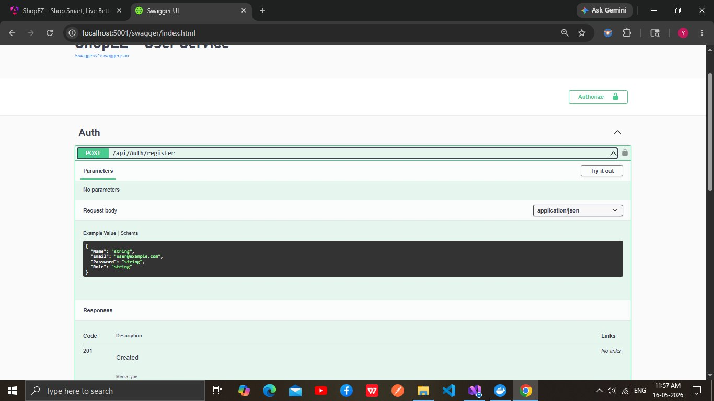
Figure 6.1a — UserService Swagger UI: POST /api/Auth/register with schema
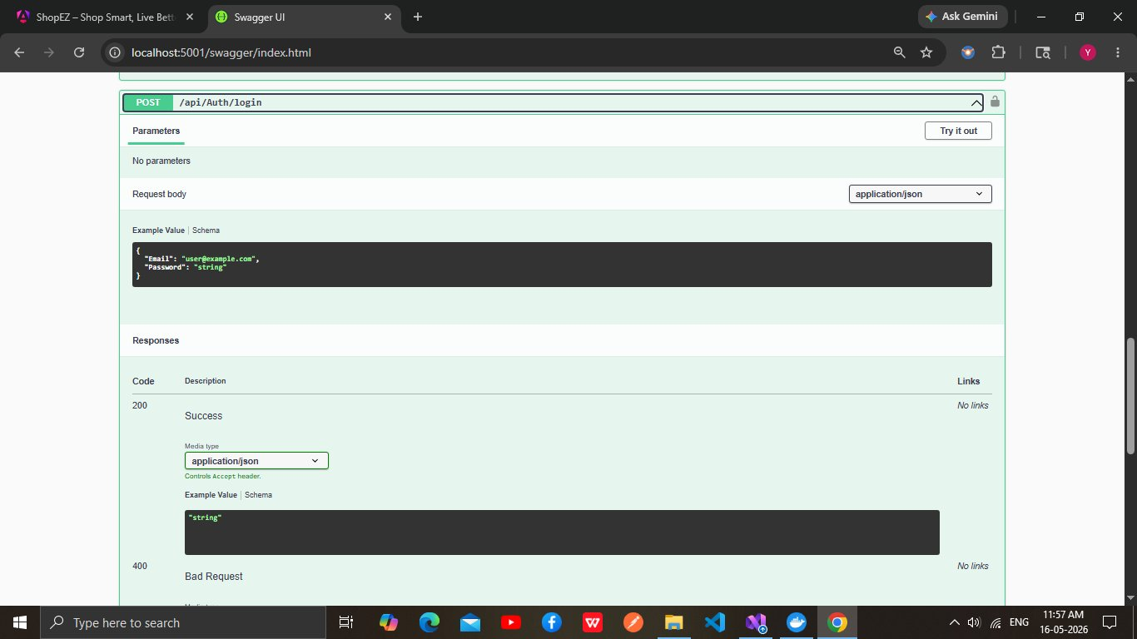
Figure 6.1b — UserService Swagger UI: POST /api/Auth/login with schema
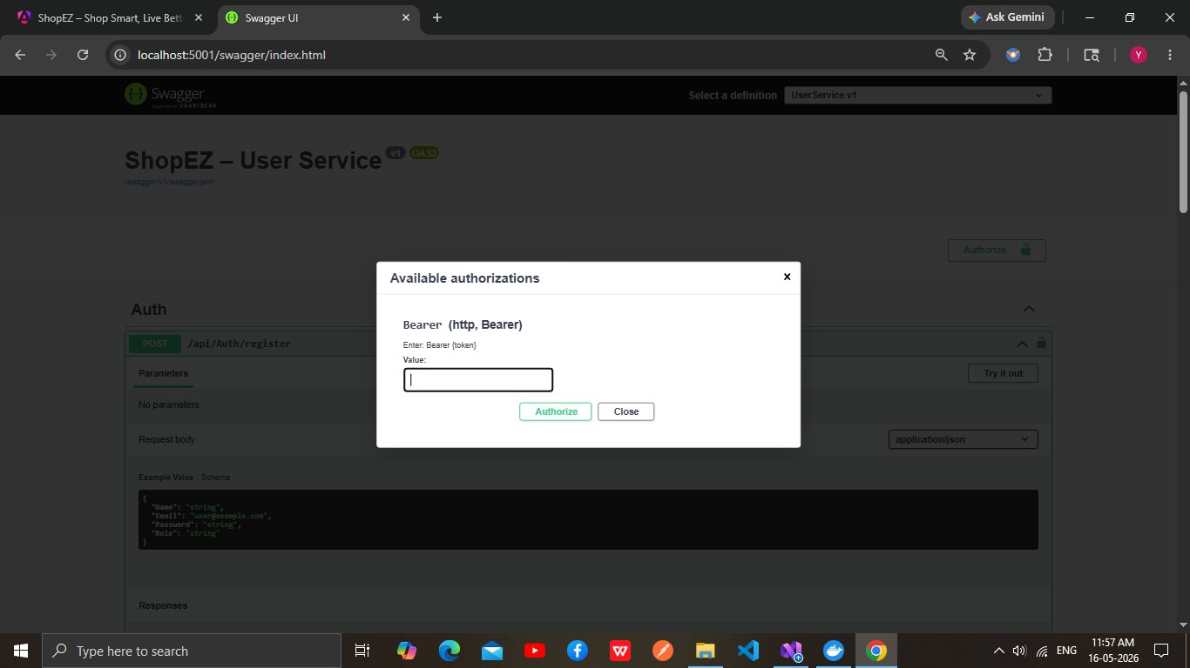
Figure 6.1c — Bearer token Authorization modal (AddSecurityDefinition)

Method | Endpoint | Auth | Description
POST | /api/auth/register | Public | Register new user. Body: {Name, Email, Password(min 6), Role}. Returns 201 with JWT token, ExpiresAt (+24h), UserId, Role.
POST | /api/auth/login | Public | Authenticate user. Body: {Email, Password}. Returns 200 with new JWT token. 401 on wrong credentials (anti-enumeration: same message for wrong email or password).

Register Request/Response
POST /api/auth/register
Content-Type: application/json

{
"Name": "Yash",
"Email": "yash05@gmail.com",
"Password": "Admin@123",
"Role": "Admin"
}

Response 201:
{
"success": true,
"data": {
"UserId": 7,
"Name": "Yash",
"Email": "yash05@gmail.com",
"Role": "Admin",
"Token": "eyJhbGciOiJIUzI1NiIsInR5cCI6IkpXVCJ9...",
"ExpiresAt": "2026-05-17T06:36:20.2002438Z"
}
}

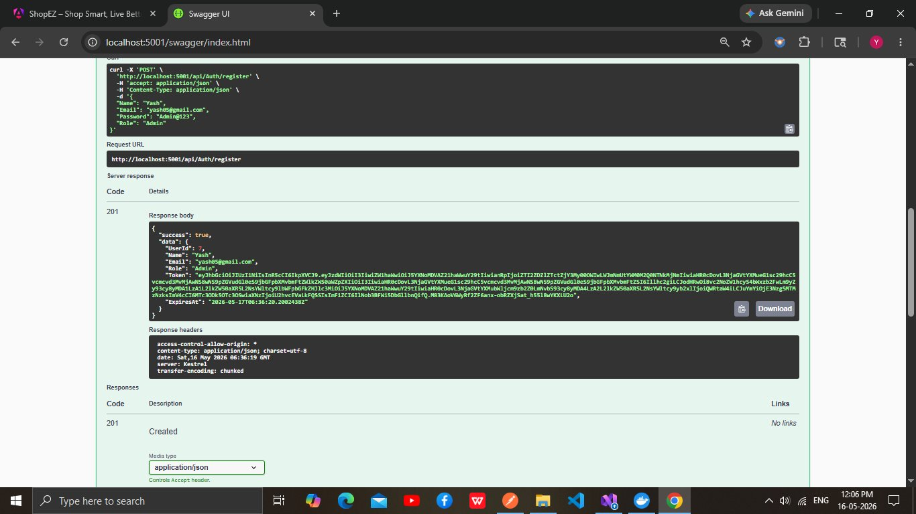
Figure 6.1d — POST /api/auth/register: 201 response with full JWT token and ExpiresAt
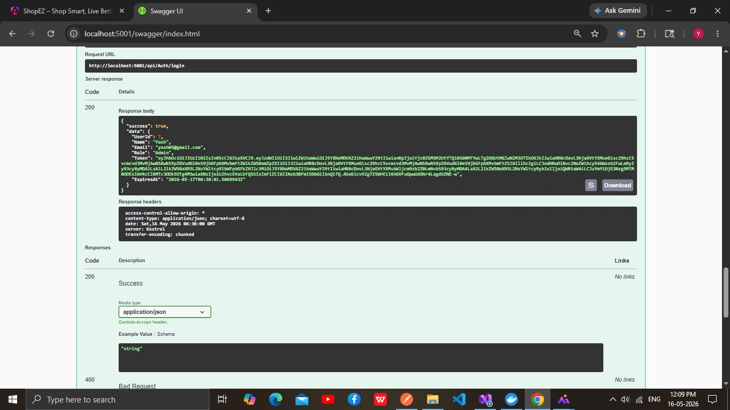
Figure 6.1e — POST /api/auth/login: 200 response with refreshed token
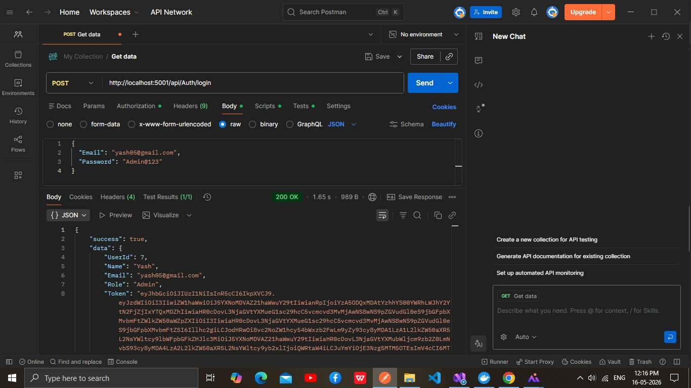
Figure 6.1f — Postman: Login 200 OK with Bearer Token set in Authorization tab
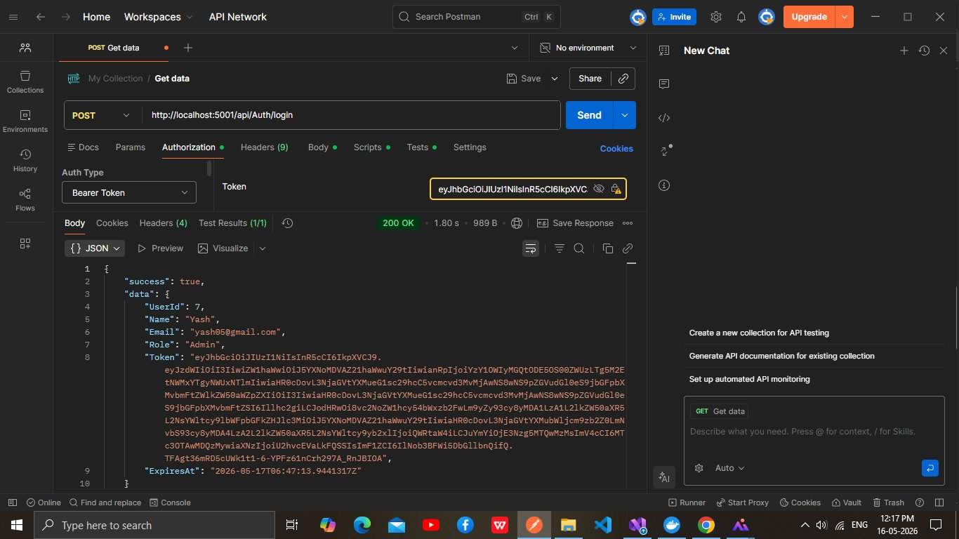
Figure 6.1g — Postman: Bearer Token configured for authenticated requests

6.2 ProductService — Product Catalogue API
Base URL: http://localhost:5000/api/products | Direct: http://localhost:5002/api/Products

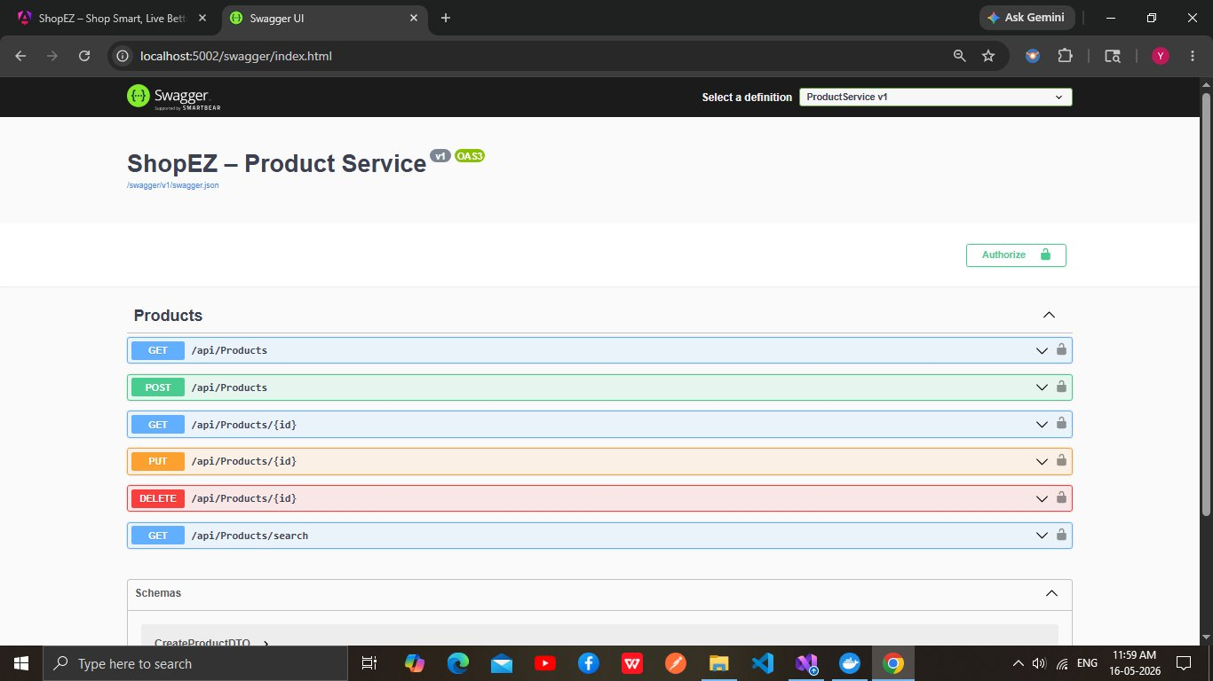
Figure 6.2a — ProductService Swagger UI: 6 endpoints with colour-coded HTTP methods

Method | Endpoint | Auth | Description
GET | /api/products | Public | Returns all products. Dapper SELECT WITH NOLOCK. PascalCase JSON.
GET | /api/products/{id} | Public | Get product by integer ID. 404 if not found.
GET | /api/products/search | Public | Paginated search. Query params: keyword, minPrice, maxPrice, minStock, page, pageSize (max 100). Returns PagedResultDTO with TotalPages, HasNext, HasPrevious.
POST | /api/products | Admin | Create product. Body: {Name, Description, Price(>0), ImageUrl, Stock(>=0)}. Returns 201.
PUT | /api/products/{id} | Admin | Update product. ExistsAsync check first. OUTPUT INSERTED.* atomic update.
DELETE | /api/products/{id} | Admin | Delete product. Returns 404 if not found.

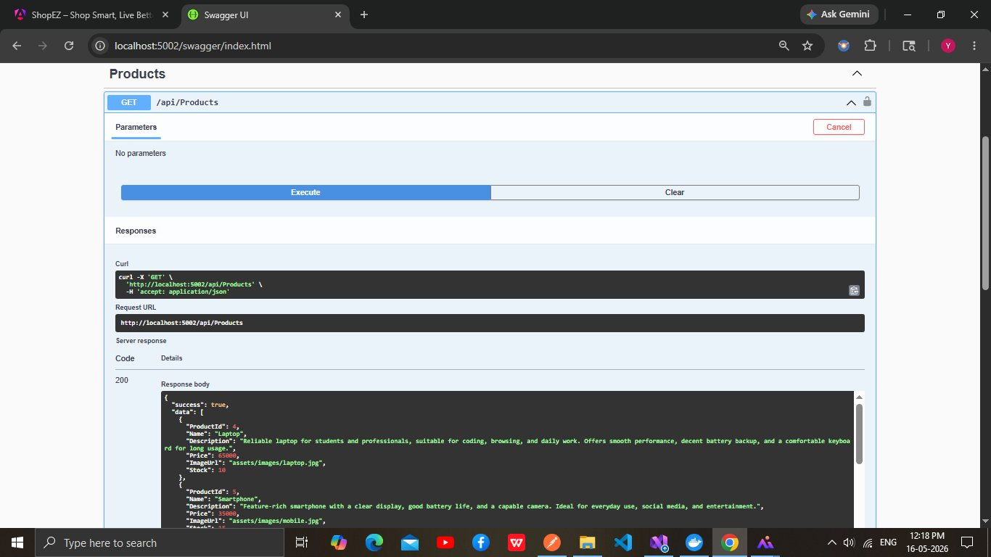
Figure 6.2b — GET /api/Products via Swagger: 200 with product array including Laptop (65000), Smartphone (35000)
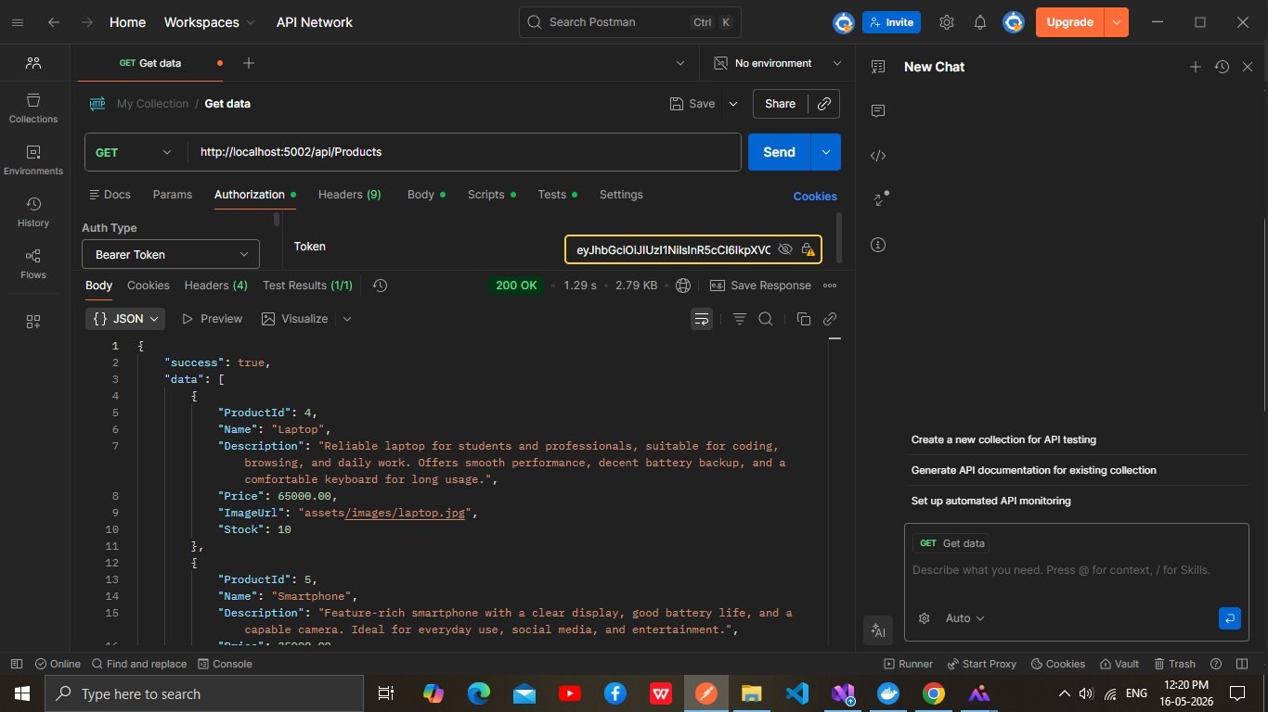
Figure 6.2c — Postman: GET /api/Products with Bearer Token — 200 OK 2.79KB in 1.29s
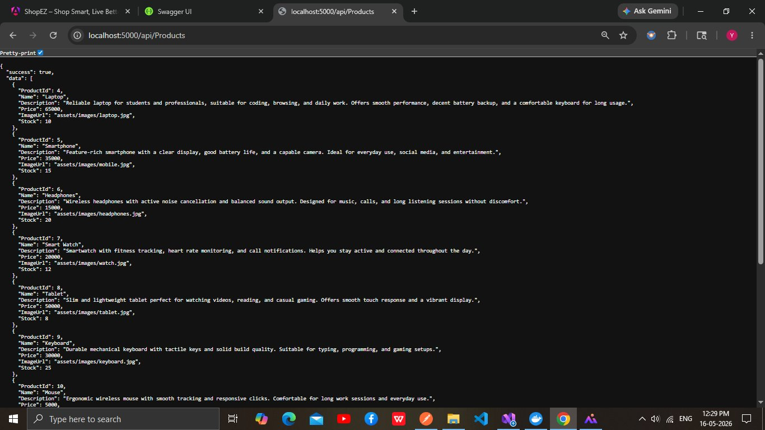
Figure 6.2d — GET /api/products via Gateway :5000 — all products rendered in browser
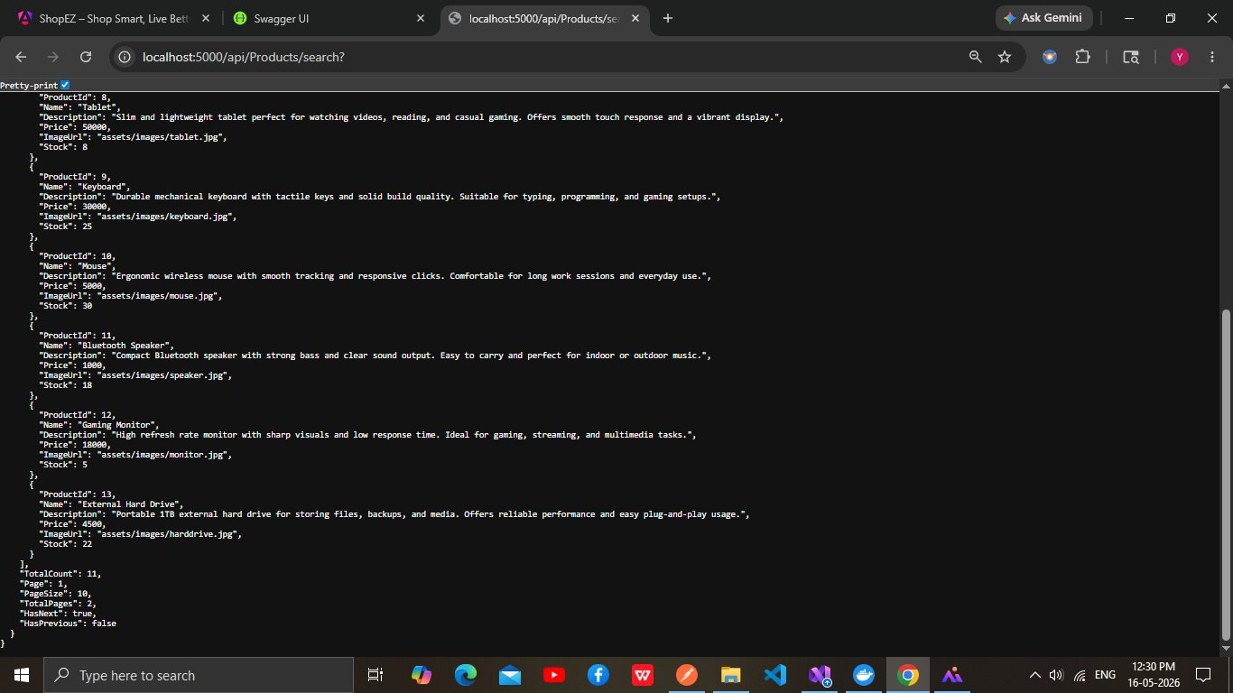
Figure 6.2e — GET /api/products/search via Gateway — PagedResultDTO with TotalCount:11, TotalPages:2, HasNext:true, HasPrevious:false

Search Response Example
GET http://localhost:5000/api/products/search?page=1&pageSize=10

Response 200:
{
"Items": [ { "ProductId": 4, "Name": "Laptop", "Price": 65000.00, "Stock": 10 }, ... ],
"TotalCount": 11,
"Page": 1,
"PageSize": 10,
"TotalPages": 2,
"HasNext": true,
"HasPrevious": false
}

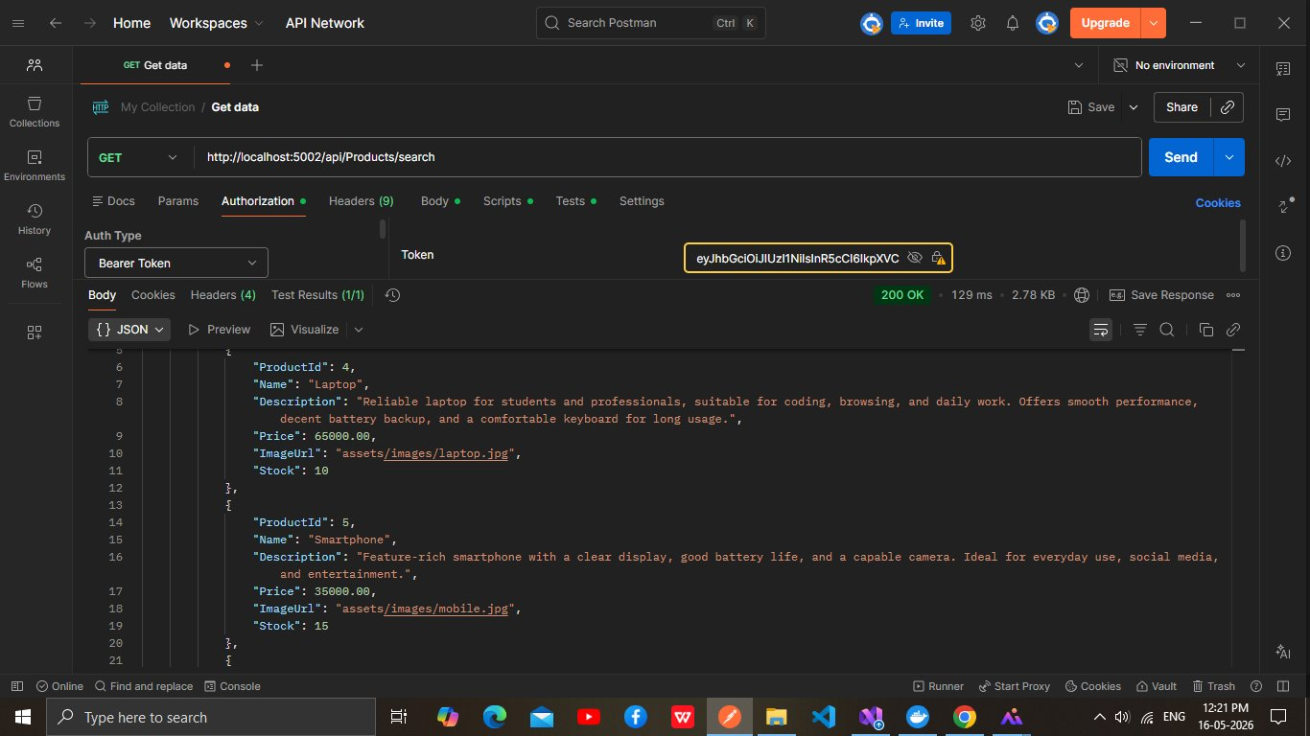
Figure 6.2f — Postman: GET /api/Products/search — 200 OK, products page 1 including Laptop and Smartphone

6.3 CartService — Shopping Cart API
Base URL: http://localhost:5000/api/cart | Direct: http://localhost:5003/api/cart

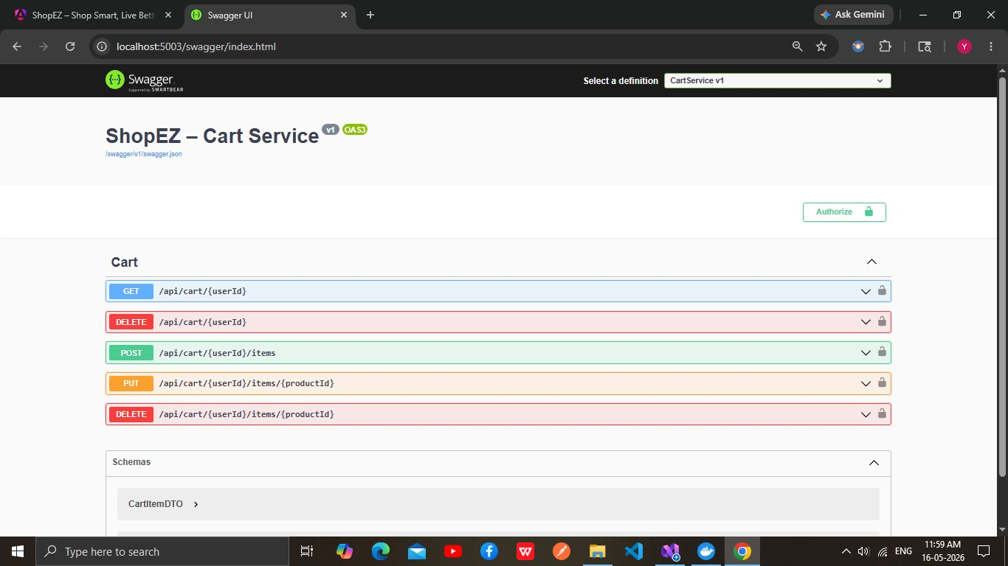
Figure 6.3a — CartService Swagger UI: 5 endpoints including nested /items routes

Method | Endpoint | Auth | Description
GET | /api/cart/{userId} | JWT | Get cart for user. Returns empty CartDTO if no cart exists. Computes Total and TotalItems.
POST | /api/cart/{userId}/items | JWT | Add item. Body: {ProductId, Name, Price, Quantity, Stock, ImageUrl}. Stock check: qty > Stock returns 400.
PUT | /api/cart/{userId}/items/{productId} | JWT | Update quantity. Body: {Quantity}. Stock check applied.
DELETE | /api/cart/{userId}/items/{productId} | JWT | Remove single item from cart. Returns updated CartDTO.
DELETE | /api/cart/{userId} | JWT | Clear entire cart. Returns 200 with success message.

6.4 OrderService — Order Management API
Base URL: http://localhost:5000/api/orders | Direct: http://localhost:5004/api/Orders

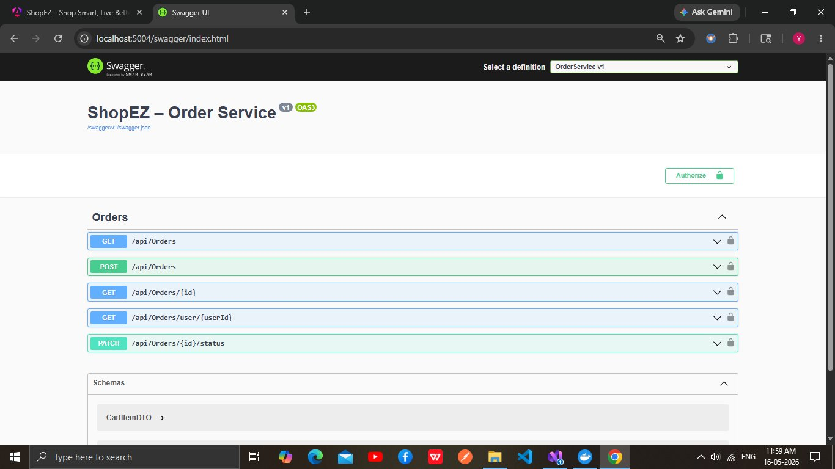
Figure 6.4a — OrderService Swagger UI: 5 endpoints including PATCH /status

Method | Endpoint | Auth | Description
GET | /api/orders | Admin | Get all orders with OrderItems. Ordered by OrderDate DESC.
POST | /api/orders | Admin/Customer | Create order. Body: {UserId, CartItems:[{ProductId,ProductName,Price,Quantity}]}. Cascade inserts Orders + OrderItems. Initial Status: Pending.
GET | /api/orders/{id} | Admin/Customer | Get order by ID with items. Subtotal computed per line (Price × Quantity).
GET | /api/orders/user/{userId} | Admin/Customer | Get all orders for a user. Ordered by OrderDate DESC.
PATCH | /api/orders/{id}/status | Admin | Update order status. Valid: Pending, Confirmed, Paid, Shipped, Delivered, Cancelled. 400 for invalid.

6.5 PaymentService — Payment Processing API
Base URL: http://localhost:5000/api/payments | Direct: http://localhost:5005/api/Payments

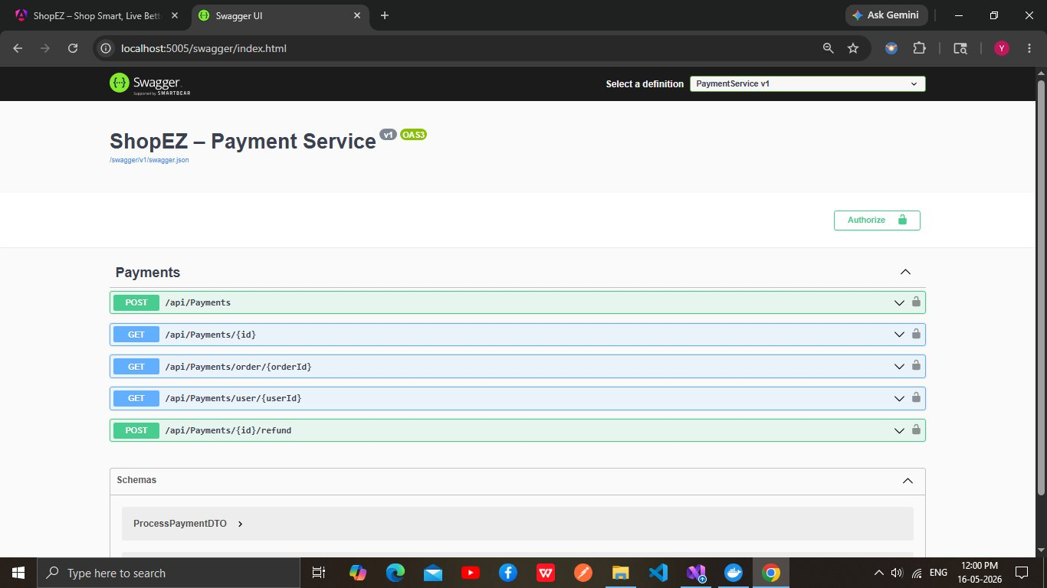
Figure 6.5a — PaymentService Swagger UI: 5 endpoints including /refund

Method | Endpoint | Auth | Description
POST | /api/payments | Admin/Customer | Process payment. Body: {OrderId, UserId, Amount, Method(Card/COD/Wallet), CardNumber, CardExpiry, CardCvv}. Unique per OrderId. Returns 402 on failure.
GET | /api/payments/{id} | Admin/Customer | Get payment by ID.
GET | /api/payments/order/{orderId} | Admin/Customer | Get payment by order ID (one-to-one via unique index).
GET | /api/payments/user/{userId} | Admin/Customer | Get all payments for a user.
POST | /api/payments/{id}/refund | Admin | Refund a Paid payment. Body: {Reason}. Returns 400 if not Paid. Sets Status=Refunded.

MockPaymentGateway Logic: CardNumber last 4 digits = '0000' → always decline ('Card declined by issuer.'); = '9999' → always timeout ('Payment gateway timeout.'); any other → 95% approval rate. COD and Wallet methods always succeed. TransactionId format: TXN-{GUID truncated to 20 chars}.

Payment Processing Example
POST /api/payments
Authorization: Bearer eyJhbGci...
Content-Type: application/json

{
"OrderId": 1, "UserId": 7, "Amount": 139.97,
"Method": "Card", "CardNumber": "4111-1111-1111-1234"
}

Response 201: { Status: Paid, TransactionId: TXN-XXXXXXXXXXXXXXXXXX }

Response 402 (card ending 0000):
{ "success": false, "message": "Payment failed: Card declined by issuer." }

7. Testing

The solution includes 5 dedicated xUnit test projects, one per microservice domain. All tests are co-located under the tests/ solution folder and reference their corresponding source project. The full test suite contains 460 passing tests (0 failures, 0 skipped) covering controllers, services, repositories, and helper utilities.

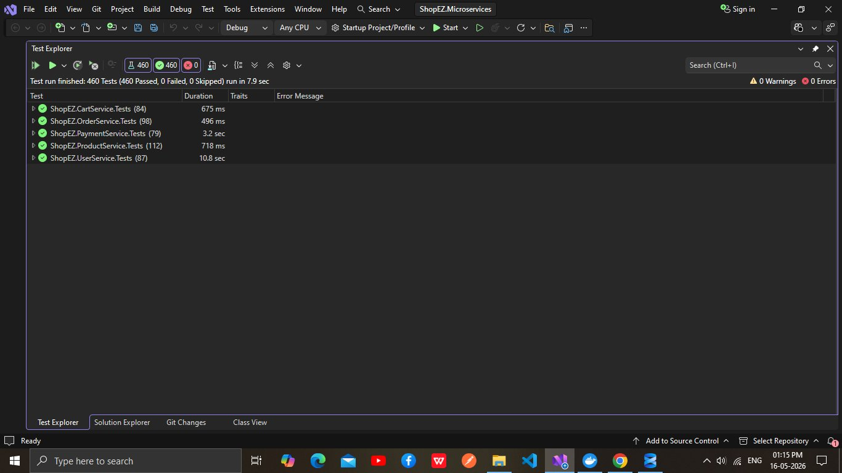
Figure 7.1 — Visual Studio Test Explorer: 460 Tests Passed (0 Failed, 0 Skipped) in 7.9 seconds

7.1 Test Distribution
Test Project | Tests | Duration | Test Classes
ShopEZ.CartService.Tests | 84 | 675 ms | CartRepositoryTests, CartServiceAddItemTests, CartServiceClearTests, CartServiceGetTests, CartServiceUpdateRemoveTests
ShopEZ.OrderService.Tests | 98 | 496 ms | OrdersControllerTests, OrderServiceCreateTests, OrderServiceQueryTests, OrderServiceStatusTests
ShopEZ.PaymentService.Tests | 79 | 3.2 sec | PaymentsControllerTests, PaymentRepositoryTests, PaymentServiceProcessTests, PaymentServiceQueryRefundTests
ShopEZ.ProductService.Tests | 112 | 718 ms | ProductsControllerGetTests, ProductsControllerMutationTests, ProductRepositoryDapperTests, ProductServiceCreateUpdateTests, ProductServiceDeleteSearchTests, ProductServiceGetTests
ShopEZ.UserService.Tests | 87 | 10.8 sec | AuthControllerTests, AuthControllerEdgeCaseTests, UserRepositoryTests, AuthServiceConfigTests, AuthServiceLoginTests, AuthServiceRegisterTests
TOTAL | 460 | 7.9 sec | 25 test classes across 5 projects

7.2 Testing Strategy

Controller Tests (Moq)
Controller tests use Moq 4.20.70 to mock the service interface (e.g., Mock<IAuthService>). The controller is instantiated directly with the mock injected. This isolates HTTP-layer concerns (status codes, response shapes, model validation) from business logic. Example: AuthControllerTests verifies that a valid RegisterDTO returns 201 with the correct AuthResponseDTO shape, and that ModelState errors return 400 before the service is ever called.

Service Tests (Moq + Interface Mocks)
Service tests mock the repository interface (e.g., Mock<IUserRepository>). Business logic paths are exercised in isolation: BCrypt hash verification, JWT generation config checks, stock validation in CartService, order total computation, and MockPaymentGateway deterministic card scenarios. AuthServiceConfigTests specifically tests the failfast behaviour when JwtSettings:SecretKey is missing or shorter than 32 characters.

Repository Tests (EF InMemory + Real CartRepository)
UserRepositoryTests and OrderRepositoryTests use Microsoft.EntityFrameworkCore.InMemory 8.0.0 to exercise EF Core queries against an in-memory database. This validates LINQ expressions (AsNoTracking, Include, AnyAsync, FirstOrDefaultAsync) without requiring a live SQL Server instance. CartRepositoryTests exercises the real CartRepository against its static ConcurrentDictionary — no mock needed.

ProductRepository Tests (Dapper)
ProductRepositoryDapperTests use Moq<ISqlConnectionFactory> to mock the Dapper connection factory, allowing the SQL string construction and DynamicParameters building logic to be tested without a database connection.

7.3 Test Execution
# Run all 460 tests from solution root:
cd Backend/ShopEZ.MicroServices.API
dotnet test --no-build -v normal

# Run single service tests:
dotnet test --filter FullyQualifiedName~PaymentService

# Run with coverage:
dotnet test --collect:'XPlat Code Coverage'

# Expected output:
Test run for ShopEZ.CartService.Tests: Passed: 84
Test run for ShopEZ.OrderService.Tests: Passed: 98
Test run for ShopEZ.PaymentService.Tests: Passed: 79
Test run for ShopEZ.ProductService.Tests: Passed: 112
Test run for ShopEZ.UserService.Tests: Passed: 87
Total: 460 Passed, 0 Failed, 0 Skipped

8. Deployment Guide

The backend is fully containerised using Docker. A single docker-compose.yml in the solution root defines all 7 services, the shopez-network bridge, and all environment variable configuration. The only external dependency is a SQL Server instance accessible from the Docker containers.

8.1 Prerequisites
Dependency | Requirement
Docker Desktop | Docker Engine 24+ with Compose V2; Linux containers mode
SQL Server | SQL Server 2019+ running on host machine; accessible at host.docker.internal:1435 with sa account
.NET 8 SDK | Required only for local development and running tests; not needed for Docker deployment
Visual Studio 2022 | 17.10+ for .slnx solution format support; optional for Docker-only deployment

8.2 Docker Deployment (Production)
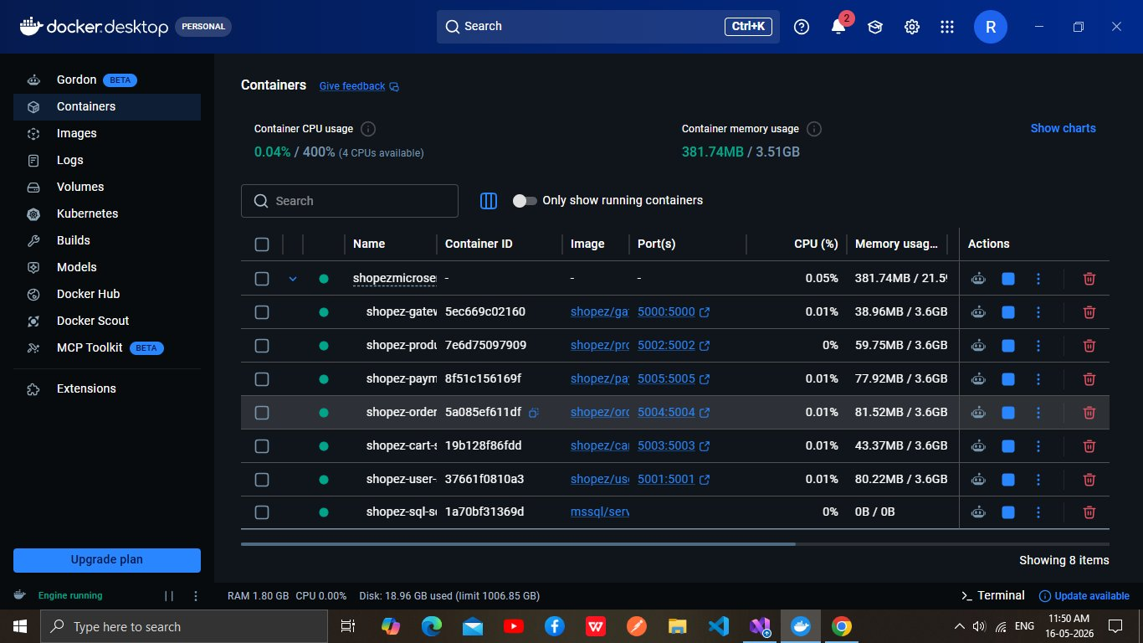
Figure 8.1 — Docker Desktop showing all 7 ShopEZ containers running on shopez-network
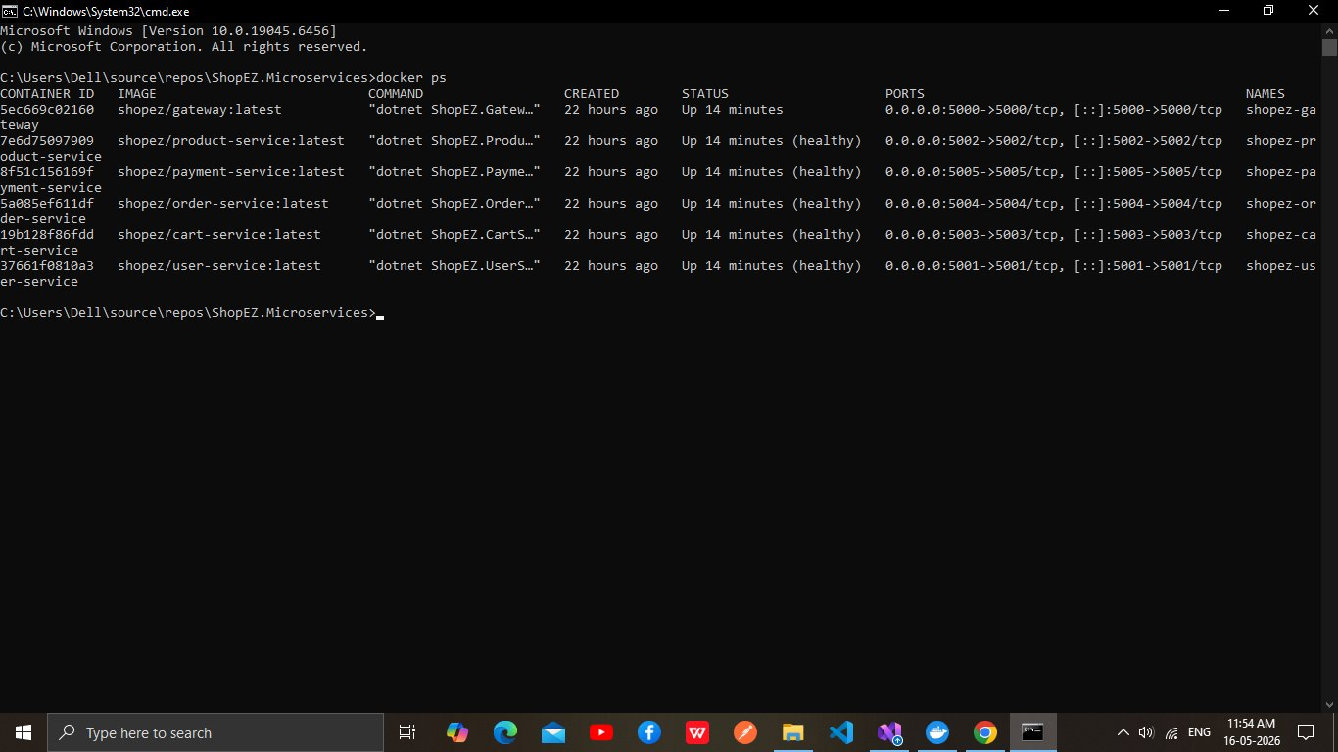
Figure 8.2 — docker ps output: all 6 services Up (healthy), ports 5000–5005 mapped

Step-by-Step Deployment
- Clone the repository and navigate to the solution root:
git clone <repo-url>
cd Backend/ShopEZ.MicroServices.API

- Ensure SQL Server is running on the host at port 1435 with sa credentials

- Build and start all containers:
docker compose up --build -d

# Container startup order (enforced by docker-compose depends_on):
# 1. sql-schema-init → creates ShopEZ_ProductDb + seeds Products
# 2. user-service → creates ShopEZ_UserDb via db.Database.Migrate()
# 3. product-service → waits for sql-schema-init to complete
# 4. cart-service → no DB dependency, starts immediately
# 5. order-service → creates ShopEZ_OrderDb via db.Database.Migrate()
# 6. payment-service → creates ShopEZ_PaymentDb via db.Database.Migrate()
# 7. gateway → waits for ALL 5 services to be service_healthy

- Verify all containers are healthy:
docker ps --format 'table {{.Names}}\t{{.Status}}\t{{.Ports}}'

# Expected output:
shopez-gateway Up (healthy) 0.0.0.0:5000->5000/tcp
shopez-product-service Up (healthy) 0.0.0.0:5002->5002/tcp
shopez-payment-service Up (healthy) 0.0.0.0:5005->5005/tcp
shopez-order-service Up (healthy) 0.0.0.0:5004->5004/tcp
shopez-cart-service Up (healthy) 0.0.0.0:5003->5003/tcp
shopez-user-service Up (healthy) 0.0.0.0:5001->5001/tcp

8.3 Environment Configuration
All services are configured via docker-compose.yml environment variables. The following variables are injected at runtime and override appsettings.Production.json:
# JWT Settings (same key shared across all 5 services for token validation)
JwtSettings__SecretKey: ShopEZ@SuperSecret#Key!2025$Secure&Long@Enough32Chars
JwtSettings__Issuer: ShopEZ.API
JwtSettings__Audience: ShopEZ.Client
JwtSettings__ExpiryHours: 24

# Per-service connection strings
ConnectionStrings__UserDb: Server=host.docker.internal,1435;Database=ShopEZ_UserDb;...
ConnectionStrings__ProductDb: Server=host.docker.internal,1435;Database=ShopEZ_ProductDb;...
ConnectionStrings__OrderDb: Server=host.docker.internal,1435;Database=ShopEZ_OrderDb;...
ConnectionStrings__PaymentDb: Server=host.docker.internal,1435;Database=ShopEZ_PaymentDb;...

8.4 Database Evidence
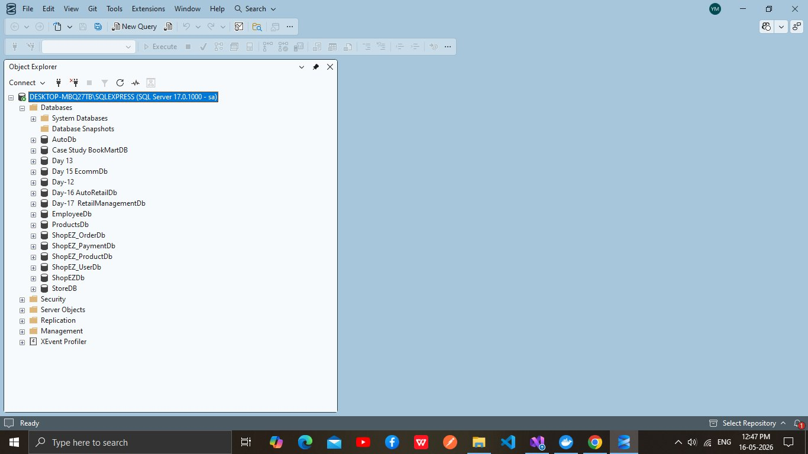
Figure 8.3 — SSMS Object Explorer: ShopEZ_OrderDb, ShopEZ_PaymentDb, ShopEZ_ProductDb, ShopEZ_UserDb all created

The four databases are created as follows: ShopEZ_UserDb — by EF Core db.Database.Migrate() in UserService startup, creating the Users table with unique index IX_Users_Email. ShopEZ_ProductDb — by the sql-schema-init container executing SqlSchema.sql, creating Products table with CHECK constraints and two covering indexes. ShopEZ_OrderDb — by EF Core migration in OrderService, creating Orders + OrderItems tables with cascade delete. ShopEZ_PaymentDb — by EF Core migration in PaymentService, creating Payments table with unique OrderId index.

8.5 Swagger UI Access
Each service exposes Swagger UI unconditionally (not gated by IsDevelopment). Access is available at:
Gateway: http://localhost:5000 (no Swagger — Ocelot only)
UserService: http://localhost:5001/swagger
ProductService: http://localhost:5002/swagger
CartService: http://localhost:5003/swagger
OrderService: http://localhost:5004/swagger
PaymentService: http://localhost:5005/swagger

8.6 Dockerfile Structure
# Multi-stage build pattern (identical across all 5 service Dockerfiles)
FROM mcr.microsoft.com/dotnet/sdk:8.0 AS build
WORKDIR /src
RUN dotnet restore --runtime linux-x64
COPY . .
RUN dotnet publish -c Release -r linux-x64 --self-contained false

FROM mcr.microsoft.com/dotnet/aspnet:8.0 AS final
# Security: creates non-root user
RUN groupadd -r appgroup && useradd -r -g appgroup appuser
RUN apt-get install -y curl # Required for healthcheck
USER appuser
EXPOSE 5001 # (varies per service: 5001-5005)
ENTRYPOINT ["dotnet", "ShopEZ.UserService.dll"]

9. Conclusion

ShopEZ successfully demonstrates a production-quality microservices backend architecture built on ASP.NET Core 8. The system achieves complete separation of concerns across six independently deployable services, each with its own database, its own authentication validation, and its own Swagger documentation. The implementation makes deliberate, code-justified technology choices — Dapper for the product catalogue's read-heavy workload, EF Core for the relational Order/Payment domains, in-memory storage for the ephemeral cart — rather than applying a uniform pattern across all services.

The 460-test suite across 5 xUnit projects, covering controllers (via Moq), services (via mocked repositories), and repositories (via EF InMemory and real ConcurrentDictionary), provides a comprehensive safety net for all business logic paths. The Docker deployment configuration with health-checked startup ordering and auto-migration on service startup demonstrates production-readiness beyond most academic implementations.

The Ocelot API Gateway centralises routing, CORS, and health aggregation, while preserving each downstream service's independence by not validating JWTs at the edge. This design allows any service to be redeployed, scaled, or replaced without changes to the gateway or other services, provided the JWT signing configuration remains consistent.

9.1 Key Achievements
# | Achievement | Implementation Evidence
1 | Microservices Architecture | 6 services, 7 Docker containers, shopez-network bridge, Ocelot 23.3.3 gateway
2 | Dual ORM Strategy | EF Core 8 (User/Order/Payment) + Dapper 2.1 (Product) with SqlConnectionFactory pattern
3 | JWT Security | HmacSha256 signing, BCrypt workFactor:12, ClockSkew=Zero, independent validation per service
4 | 19 REST Endpoints | Full CRUD across 5 domains; RBAC (Admin/Customer/Public) enforced via [Authorize(Roles)]
5 | 460 Passing Tests | 25 test classes, 5 projects, 7.9s total run time, 0 failures
6 | Database Isolation | 4 separate SQL Server databases; auto-migration (3 services); DDL-init (1 service)

10. Future Scope

The current ShopEZ implementation establishes a solid microservices foundation. The following enhancements are identified from gaps in the current codebase and represent logical next steps for a production deployment:

Enhancement Area | Description & Code Basis
Stock Deduction on Order | IProductRepository.DeductStockAsync(productId, quantity) is implemented in ProductRepository with atomic SQL (UPDATE Products SET Stock = Stock - @Qty WHERE Stock >= @Qty) but is never called from OrderService. Wiring this into OrderService.CreateOrderAsync would complete the inventory management loop.
Cart Persistence (Redis) | CartRepository currently uses a static ConcurrentDictionary (data lost on restart). Replacing ICartRepository with a Redis-backed implementation would provide persistence across deployments without changing the controller or service layer (interface contract is preserved).
Inter-Service Events (RabbitMQ/Kafka) | Currently there is no service-to-service communication. An event bus would enable: OrderCreated → CartService clears cart; PaymentCompleted → OrderService updates status to Paid automatically, instead of requiring a manual Admin PATCH call.
JWT Validation at Gateway | Ocelot supports AuthenticationOptions on routes. Adding gateway-level JWT validation would provide a security defence layer before requests reach downstream services, reducing invalid JWT traffic.
Structured Logging (Serilog) | Current logging uses ASP.NET Core built-in ILogger with console output. Replacing with Serilog + Seq or Elastic Stack would enable distributed tracing with correlation IDs across the 5 services.
Global Exception Middleware | Each controller has its own try/catch pattern (identical across all 5 services). A single custom middleware class (IMiddleware) implementing the AppException-to-StatusCode mapping would eliminate this duplication.
Real Payment Gateway | MockPaymentGateway.cs (static class) can be replaced with a Stripe/Razorpay implementation by implementing the same charge signature: (cardNumber, amount, method) → (bool success, string transactionId, string failureReason). No service layer changes required.
Kubernetes Deployment | The existing Dockerfiles and health check endpoints (/health) are Kubernetes-ready. Translating docker-compose.yml to Kubernetes Deployment + Service + Ingress manifests with HPA for ProductService and CartService would enable cloud-native horizontal scaling.
CI/CD Pipeline | The 460-test suite provides a robust CI gate. A GitHub Actions workflow could: run dotnet test, build Docker images, push to registry, and deploy to a Kubernetes cluster on every PR merge.

📊 Future Architecture — With Event Bus and Redis
mermaid
graph TB
Client --> GW[Ocelot Gateway\n+JWT Validation]
GW --> US[User Service]
GW --> PS[Product Service]
GW --> CS[Cart Service\nRedis-backed]
GW --> OS[Order Service]
GW --> PAY[Payment Service\nReal Gateway]
OS -->|OrderCreated event| EB[Event Bus\nRabbitMQ/Kafka]
PAY -->|PaymentCompleted event| EB
EB -->|Clear cart| CS
EB -->|Update status| OS
EB -->|Deduct stock| PS
style EB fill:#E67E22,color:#fff
style GW fill:#1B4F9E,color:#fff

